Chapter 3

Types and Interfaces

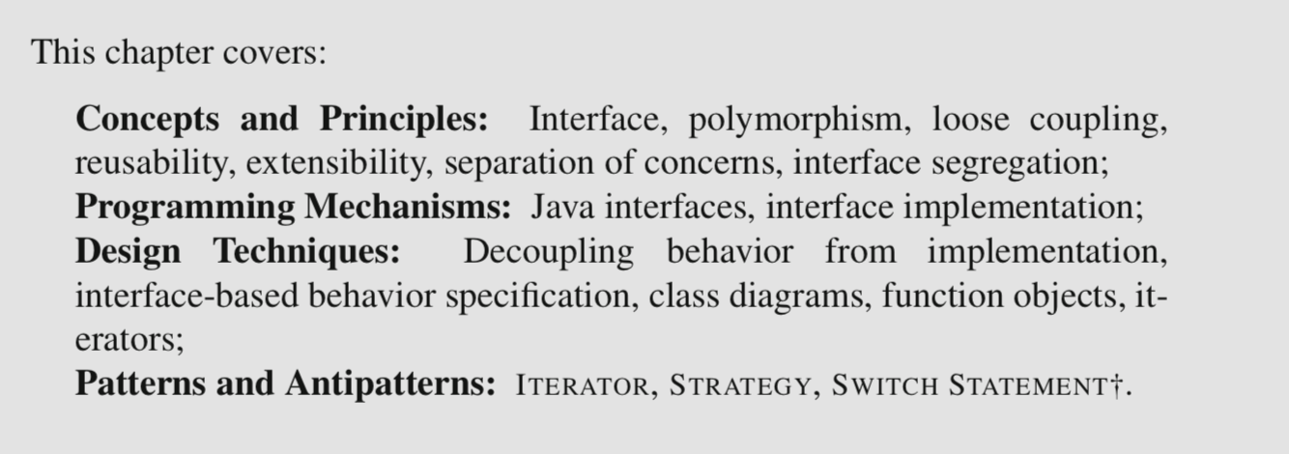

3.1 Decoupling Behavior from Implementation

An interface

* to a **class** consists of the methods of that class that are accessible (or visible) to another class.
* to an **object** is the set of methods that can be called on the object.

Interfaces provide a specification of the methods that it should be possible to invoke on the objects of a class. So we could define an abstraction CardSource as any object that supports a draw() and isEmpty() methods:

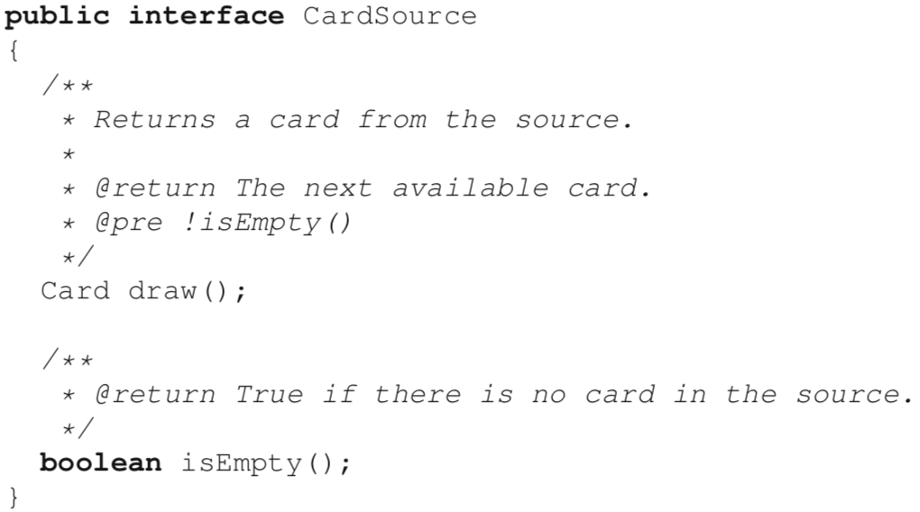

To tie a class with an interface, we use the **implements** keyword.



* It provides a formal guarantee that instances of the class type will have concrete implementations for all the methods in the interface type. This guarantee is enforced by the compiler.
* It creates a subtype relationship between the implementing class and the interface type: here we can now say that a Deck is a type of CardSource.

The subtype relation between a concrete class and an interface is what enables the use of polymorphism. In plain language, polymorphism is the ability to have different shapes. Here, CardSource is an **abstraction** that can present itself in different concrete shapes. Each concrete shape corresponds to a different implementation of the CardSource interface.

For polymorphism to be useful in code, it is important to remember that according to the rules of the Java type system, it is possible to assign a value to a variable if the value is of the **same type or a subtype** of the type of the variable. Because the interface implementation relation defines a subtype relation, references to objects of concrete classes declared to implement an interface can be assigned to variables declared to be of the interface type. For example, because class Deck declares to implement interface CardSource, we can assign a reference to an object of class Deck to a variable of type CardSource, as such:

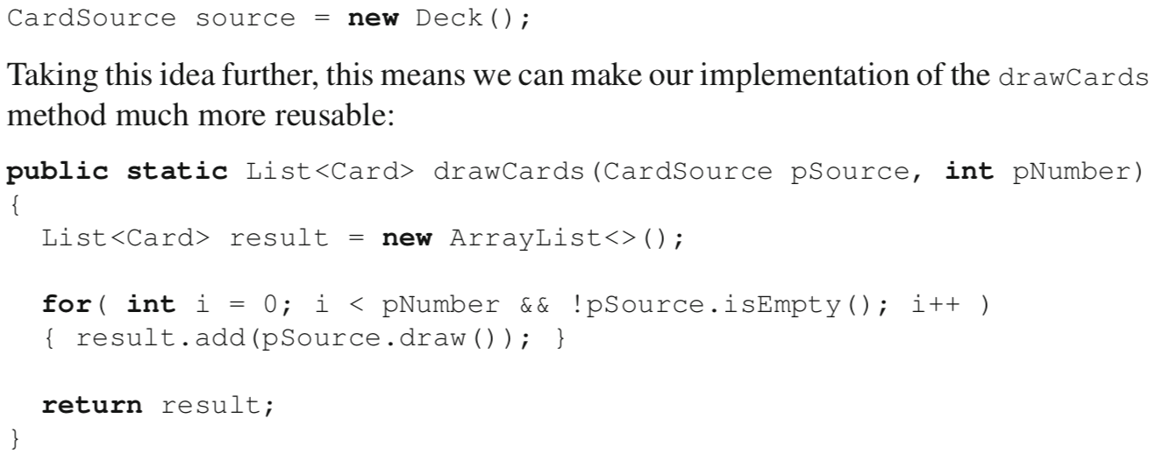

[Another example]

Another illustration of the use of polymorphism is the use of **concrete vs. abstract** collection types in the Java Collections Framework.



Here List is an interface that specifies the obvious services (add, remove, etc.), and ArrayList is a concrete implementation of this service that implements the list using an array structure. But we can just as well replace ArrayList with LinkedList and the code will still compile. Even though the details of the list implementation differ between ArrayList and LinkedList, they both provide exactly the methods required by the List interface, so it is permissible to swap them. Polymorphism provides two useful benefits in software design:

* **Loose coupling**, because the code using a set of methods is not tied to a specific implementation of these methods.
* **Extensibility**, because we can easily add new implementations of an interface (new “shapes” in the polymorphic relation).

3.2 Specifying Behavior with Interfaces

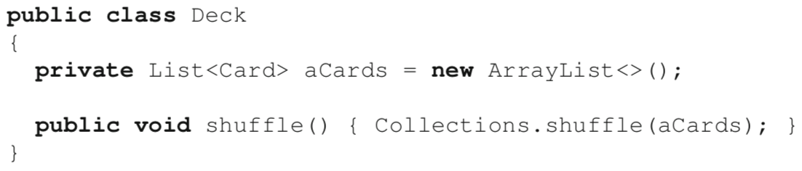

This is an example of code reuse because it is possible to **reuse the library method** to reorder any kind of collection. Here reuse is easy because to shuffle a collection, we do not need to know anything about the items being shuffled.

Problems occur when we want to *sort* our cards.

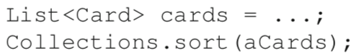 compilation error

Comparable<T>

The Comparable<T> interface defines a piece of behavior related specifically to the comparison of objects, in the form of a single int compareTo(T) method. The specification for this method is that it should return 0 if the implicit argument is the same as the explicit argument, a negative integer if it should come before, and a positive integer if it should come after. Given the existence of this interface, the internal implementation of Collections.sort can now rely on it to compare the objects it should sort. Conceptually, the internal code of the sort implementation looks a bit like this:

if( object1.compareTo(object2) > 0 ) ...

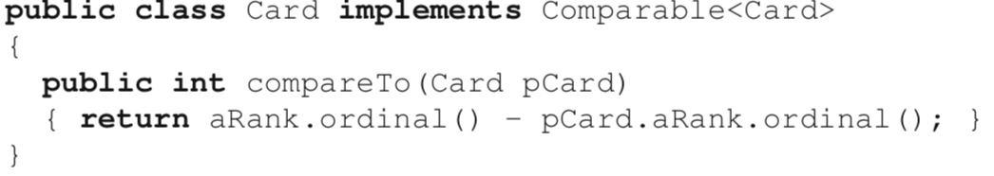

by ascending rank, but leaves the order of suits undefined

Because interfaces are types, the type checking mechanism that is part of the compilation process makes it possible to detect that a List<Card> object cannot be passed to Collections.sort unless the Card class declares to implement the Comparable<Card> interface.

Many other library types that have a so-called “natural” ordering implement the Comparable interface. This includes String (with alphabetical order) but also many other pervasive types. In particular, Java enumerated types implement Comparable by comparing instances of an enumerated type according to their ordinal value.

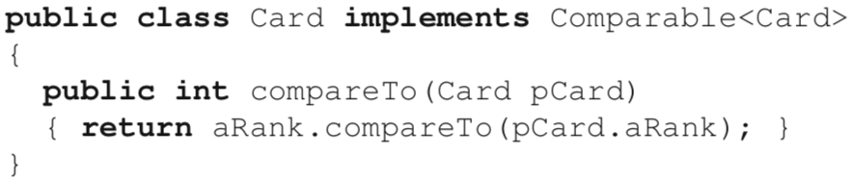

Using small interfaces encourages the respect of a software design principle called separation of concerns. The idea of separation of concerns is that *one abstraction should map to a single “concern” (or area of interest) for developers.* In designs that do a poor job at separation of concerns, we find concerns to be tangled within an abstraction (a method for example), and/or scattered across multiple different abstractions. Here the use of the Comparable interface is a good example of effective separation of concerns: the code to compare cards is entirely contained within a clearly defined and identified abstraction (the compareTo method), which does only one thing.

3.3 Class diagrams

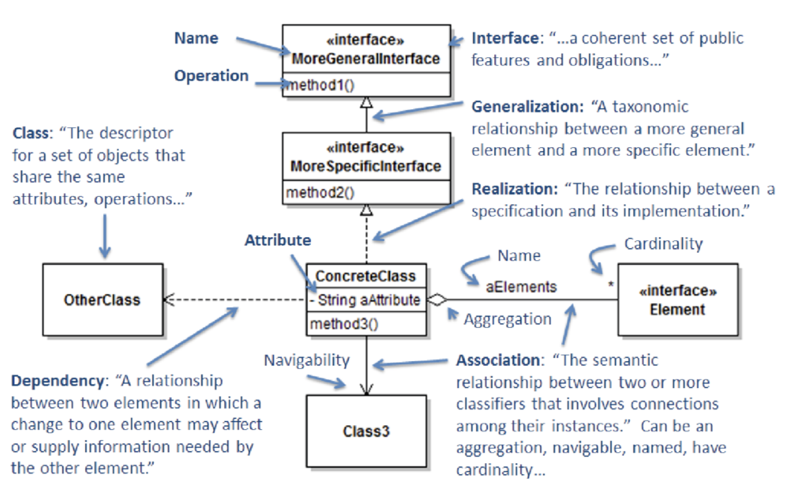

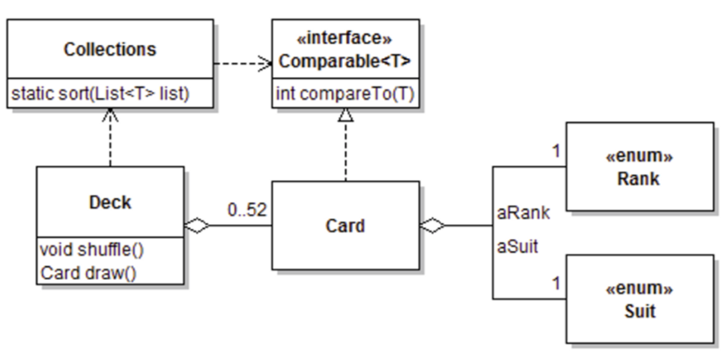

3.4 Function Objects

A common case when using Java interfaces is that an interface represents only a sub- set of the complete interface of classes that implement it. This case is exemplified by Comparable: the complete implementation of Card comprises methods (e.g., getSuit() and getRank()) that add to the slice of behavior mandated by the interface. There are other situations, however, where it is convenient to define classes that specialize in implementing **only the behavior required by a small interface with only one method.**

To illustrate this point, let us continue with the problem of comparing cards. Implementing the Comparable interface allows instances of Card to compare themselves with other instances of Card using one strategy, for example, by comparing the card’s rank, and using suits to break ties. What if we are designing a game where it makes sense to sort cards according to different strategies, and occasionally switch between them? One could tweak the code of compareTo, for instance by setting a flag in an instance of Card and switching the comparison strategy on this flag. However, harebrained schemes of this nature have many drawbacks. In our case, using such a flag instance variable:

* Would destroy the immutability of the Card class;
* Would degrade the neat separation of concerns between representing a card and knowledge of how the card should be sorted at a particular moment in the execution of the code.

In fact, the use of this kind of “switching” approach is often considered poor form, and this programming idiom is considered a design antipattern called SWITCH STATEMENT†.

Note: There is evidence of the antipattern whether or not an actual switch statement is used, since the latter can be trivially emulated through if–else statements.

A more promising solution is to move the comparison code to a separate object. This solution is supported by the Comparator<T> interface. The most important method in this interface is compare (as opposed to compareTo).

’

The method takes two arguments instead of one. Indeed, its specification is very similar to that of compareTo, except that instead of comparing the implicit parameter (the **this** object) with an explicit parameter, it compares two explicit parameters with each other.



This method can sort a list of objects that do not necessarily implement the Comparable interface, by taking as argument an object guaranteed to be able to compare two instances of the items in the list.

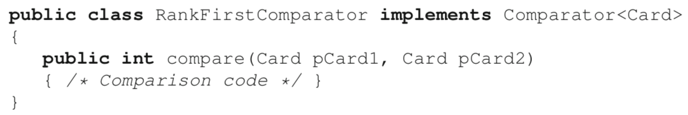

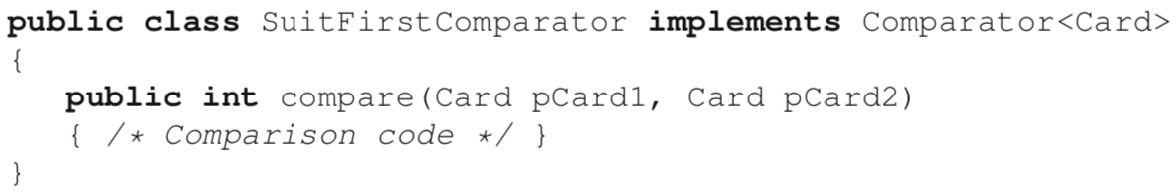



In this scenario, an instance of Comparator is simply an object that provides the implementation for a **single** method. In Java terminology, these are often referred to as function objects.

[trade-off]

First, if comparator classes are defined as standalone top-level Java classes, the code of their compare method will **NOT have access to the private members of the objects they compare.** In some cases the information available from getter methods is sufficient to implement the comparison, but in other cases implementing the compare method will require access to private members.

First option: Declare the comparator classes as nested classes of the class that defines the objects being compared:

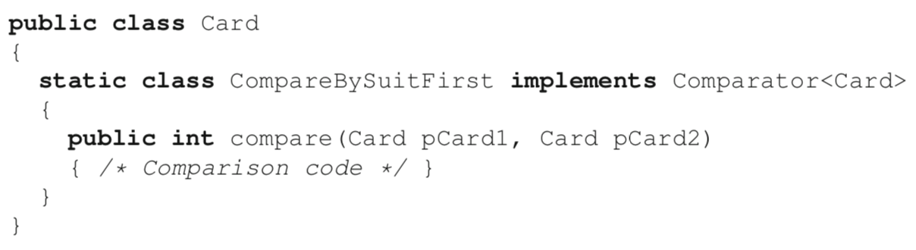



Second option: Define comparator classes as anonymous classes (especially where the comparator is only referred to once)

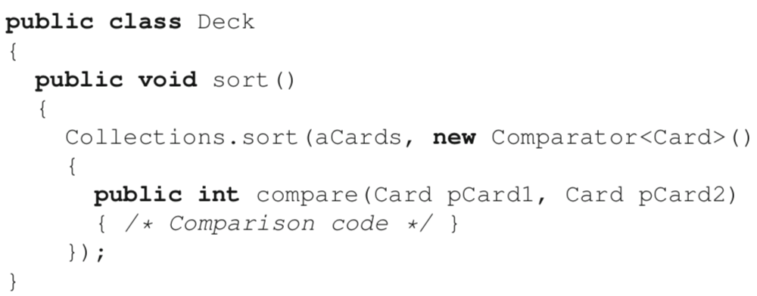

Third option: Lambda expressions are a form of anonymous function. The basic idea is based on the observation that to supply a comparator, not only do we NOT need to name a class because it is only an implementation of the Comparator interface, we also do NOT need to name the method, because it is only an implementation of compare.

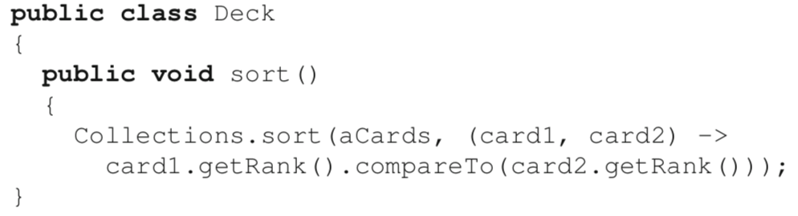

In the two examples above, we have brought back the problem of encapsulation, because the code in the anonymous class that implements the comparison is defined outside of the Card class. We can solve this with the help of a static *factory method*. I use the term “factory method” to denote any method whose primary role is *to create and return an object*.



A final question is whether a comparator should store data. For example, instead of having different comparators for sorting cards by rank and suit, we could define a UniversalComparator that has a field of an enumerated type that stores the desired type of comparison. Although this solution is workable, it can lead to code that is harder to understand, for reasons explained in Section 3.7 and further discussed in Chapter 4.

3.5 Iterators

A common requirement when designing data structures is to gain access to a collection of objects encapsulated by another object without violating encapsulation and information hiding. This problem was originally introduced in Section 2.7, where the solution proposed was to return copies of the internal data. For example, to return a copy of the list of cards encapsulated within a Deck instance. One issue with this solution is that it can subtly leak information about the way a structure is stored internally (or at least, give the impression that it leaks this information). For exam- ple, if we choose to return a deck’s cards as a List:

public List<Card> getCards() {...}

Code using the Deck may start relying on the operations defined on a list, or make the assumption that cards are internally stored in a list within a Deck. To achieve an even higher level of information hiding, it would be best to allow client code access to the internal objects of another object, **without exposing anything about the internal structure of the encapsulating object.** This design feature is supported by the concept of an iterator.

Iterator interface defines two abstract methods: hasNext() and next(). So, according to the rules of subtyping, once a piece of code gains access to a reference to an object of any subtype of Iterator, the client code can iterate over it, independently of what the actual class of the object is.

To enable iteration over the cards of a Deck, let us simply redefine the getCards method to return an iterator instead of a list:



Although this design achieves our decoupling goal, we can generalize it to great effect. A first important insight is that in most software there will typically be many different types of objects that it would be useful to iterate over. Lists are an obvious example. In our case we have a Deck. In practice, the list of possibilities is infinite. The issue with the iterator system as we have it now, though, is that every class defines a **different** way to obtain an iterator. For class List, it is through the method iterator(). For our Deck class, it is through method getCards(). Although the behavior in both cases is **identical (return an iterator)**, the name of the service is different. We can solve this issue with an interface. The Iterable<T> interface specifies the smallest “slice” of behavior necessary to make it possible to iterate over an object. To be able to polymorphically iterate over an object, the only thing we need from this object is that it supplies an iterator. So the only abstract method of the Iterable interface is Iterator<T> iterator().

We can make our Deck class iterable by implementing the Iterable<Card> interface and renaming the getCards() method to iterator():





One of the main ways to use Iterable objects in Java is in enhanced for (a.k.a. for each) loops



an instance of a class that is a subtype of Iterable



Note: List contained within a Deck is also Iterable

3.6 The ITERATOR Design Pattern

*Provide a way to access the elements of an aggregate object sequentially without exposing its underlying representation.*

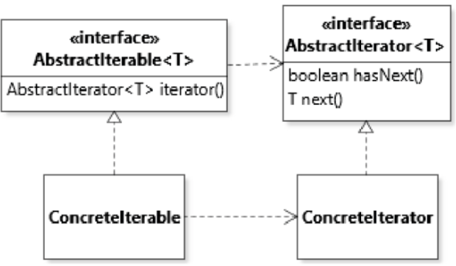

return the iterator supplied by the data structure (e.g., ArrayList.iterator()).

3.7 The STRATEGY Design Pattern

*Define a family of algorithms (algorithms in the same family implement the same interface), encapsulate each one, and make them interchangeable.* Strategy *lets the algorithms vary independently from clients that use it.*

The part of the design is focused on allowing the **switch** between algorithms.

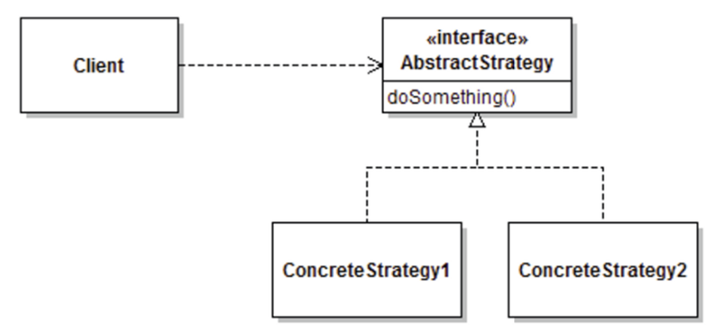

e.g. Different card comparators for a deck of cards.

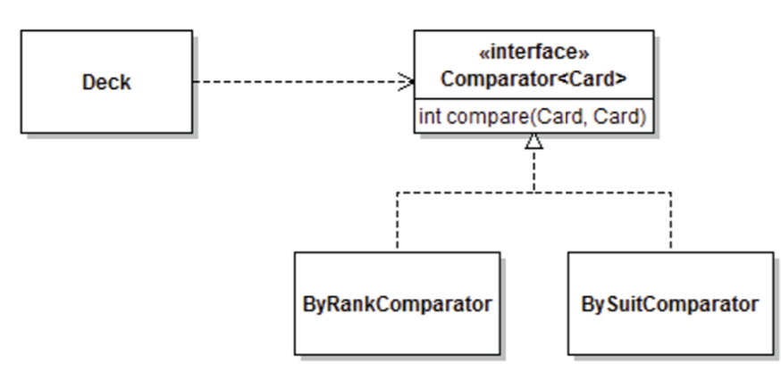

3.8 The Interface Segregation Principle (ISP)

*The client code should not be forced to depend on interfaces it does not need.*

[Example]

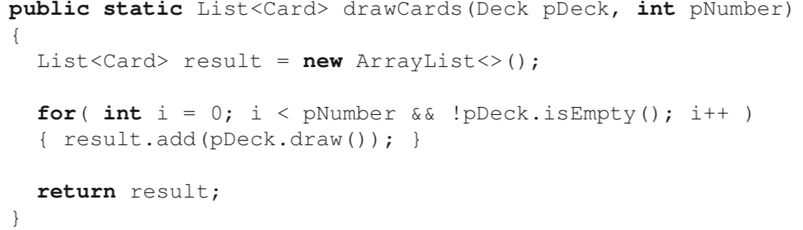

Suboptimal: It tied an interface with its implementation.

Split the two by declaring an IDeck interface:

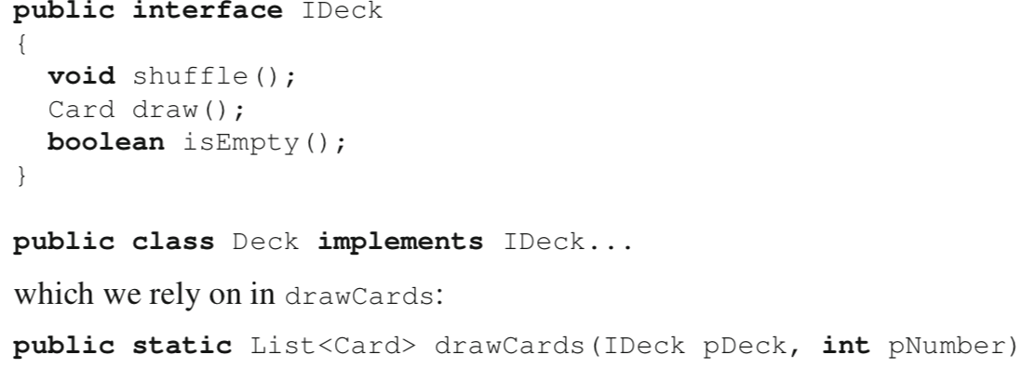

Suboptimal: It forces drawCards to statically depend on a method it does not need (shuffle). What if we might want to draw cards from a source that cannot be shuffled? For this reason, the CardSource solution initially presented in Section 3.1 did respect the ISP, and only included methods draw and isEmpty in interface CardSource.

To push on this idea of ISP a bit, let us assume that there might be places in the code that only shuffle an object. To support this slice of behavior, we would define an interface Shufflable with a single method shuffle().

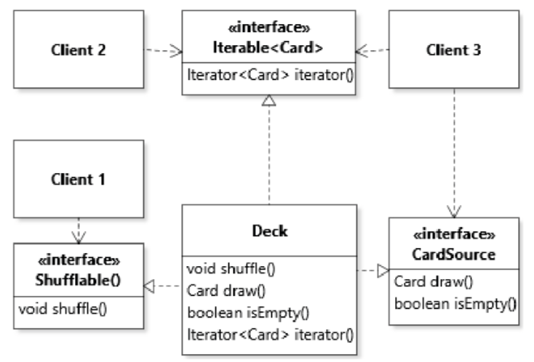

This design has loose coupling, which is great. However, this loose coupling has one major disadvantage for cases where a client might be interested in **more than one** slice of behavior. This situation is represented in by Client 3, which needs to both iterate over an Iterable<Card> AND draw some cards from the source.

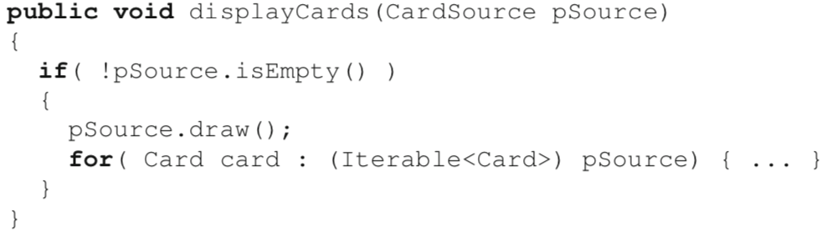

Inelegant & unsafe: It could be possible to provide an argument to displayCards that is not a subtype of Iterable.

A better solution to this issue is offered directly by the type system, in the form of subtyping. In Java, interfaces can be declared to extend each other, with the semantics that if A extends B, types that implement A must provide implementation for all the methods declared in B as well, transitively. By extending interfaces, we can more easily support combinations of services while respecting the ISP. In our scenario, if it is observed that a lot of the code that uses CardSource also uses Iterable<Card>, but not the other way around, then we can declare CardSource to be a subtype of Iterable<Card>

